**Lab 1a Creating a Virtual install of Kali using VMWare**

**Caveat**

Be sure to read the lab in its entirety before stating this or any lab in the course! Skipping a step in any part of the lab will cause the lab to fail. Trying to blow through this lab will result in epic failure! Slow and steady wind the race.

**Requirements:**

1. Kali Linux Preinstalled Image: (**~3.6 GB**)
2. VMWare: (**~107 MB**)
3. CPU that supports Virtualization.
4. 8GB of RAM preferred. (4 GB of RAM will Suffice but is not optimal)
5. At least 60 GB of free hard drive space. (An external hard drive or thumb drive can also be used as storage)

**Using Other Hypervisors**

For all the gunslingers in the course, if you are using some other hypervisor to create your virtual lab environment, you are good to go. No need to check with the instructor.

This lab, will walk through the creation and installation of a Kali Linux virtual machine inside VMWare using a prebuilt Kali image. Kali will function as our attack machine for all subsequent labs.

**How much time to allocate for this lab**

The whole process may take a few hours to complete depending on the specifics of your own situation, i.e., computer, internet connection speed, and so on.

Any software references in the lab is free and open source, just like Kali.

As the lab begins, students will be taken through the download process for any downloads. All software has been verified to be malware and crapware free.

**Begin the lab!**

**Install Kali Linux in VMWare (using and OVA file)**

**1. Download and install VMWare**

There is no version of VMware Player for OS X (MAC, Apple). Instead, VMware sells a Mac version of their product called [VMware Fusion](http://www.vmware.com/products/fusion). You may use it as a 30 day free trial version. If you don't want to purchase VMware Fusion, you can:

* Purchase and install Parallels for MAC to create a virtual install of Kali Linux
* Use VirtualBox. VirtualBox is free and can use the same OVA image file downloaded for this lab.

The first step is to download and install the **VMWare** software package onto the host machine chosen for your lab setup. Make sure your hardware is 64bit as this is the only version available for VMWare.

Once downloaded, **VMWare** installs like any other software program. Find your download and begin installing. **VMWare** is malware, adware, spyware, and crapware free.

[Download here!](http://www.vmware.com/products/player/playerpro-evaluation.html)

**2. Download and install Free Download Manager**

Download managers allow you schedule, start, stop, and resume a download without loss of any downloaded progress. When we are downloading gigabytes of data, being almost, having the download interrupted and having to start over is very frustrating. Download managers can also reduce up your download time.

For this lab, I used a download manager called **Free Download Manager**.

Install the free download manager onto your host machine. Find your download and begin the installing. The **Free Download Manager** is malware and crapware free.

[Download here!](http://www.freedownloadmanager.org/)

**3. Download the Right Kali image**

**Important note!**

**This lab uses the prebuilt image built for VMWare. The VMWare image is built and packaged using the ‘Open Virtualization Format’ (OVF).**

**In September 2007 VMware, Dell, HP, IBM, Microsoft and XenSource submitted to the Distributed Management Task Force (DMTF) a proposal for OVF, then named "Open Virtual Machine Format"**

**Do not download the Kali image for VirtualBox! Download the image built for VMWare! The VMWare image is much smaller than the one built for VirtualBox. It took me roughly 2.5 hours to update as opposed to the VirtualBox image which much less time.**

Using a pre-installed file saves us a lot of time as we won’t have to step through the installation process.

For install method, we need to use the Free Download Manager to ensure our download is uninterrupted and timely.

Since the Kali images are updated over time, the file for the download will differ than what is in the lab but it is remains the same file just with updates. Visit the [Offensive Security download page](https://www.offensive-security.com/kali-linux-vmware-virtualbox-image-download/) for the latest image.

Once you’re on the right download page, your choice if which download to choose from is either number 1 or number 2. If your system 64bit, use the first download. If your system is 32 bit, use the second download. Select your download method.

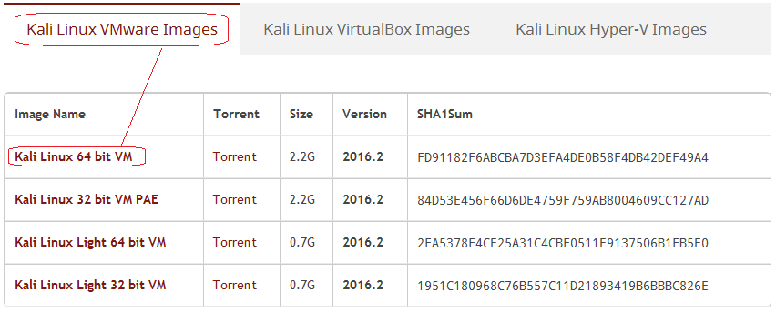

If your Free Download Manager is associated with your browser, it should automatically open and prompt you to start the download. If not, just right click on the download method and select, Copy link location.

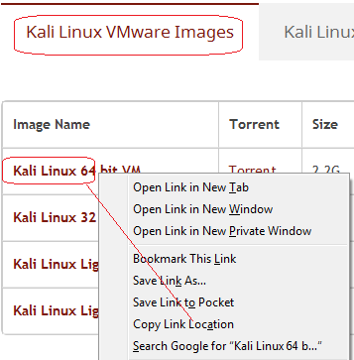

Open you Free Download Manager and click on the + sign in the upper left corner. The **Add Download** box appears. The link is already inserted. Click OK and the download starts.

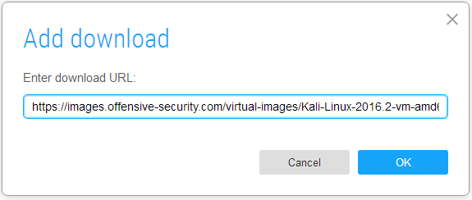

I choose to use a straight download as I have found there is not much difference in the time it takes to download this image one way or the other.

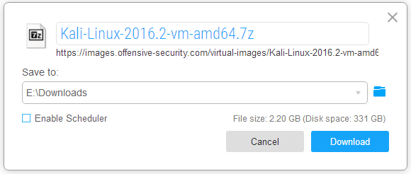

The same method used to get the normal download link applies for either the image or the full ISO image.

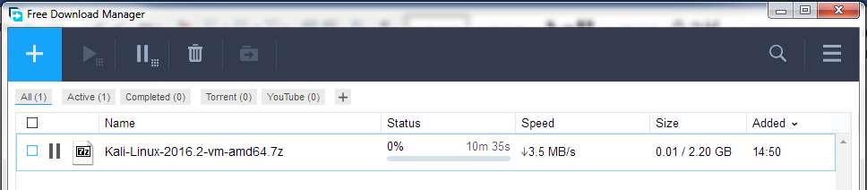

**Install the 7zip archiving utility.**

7zip is used as file compression utility much like Winzip of WinRar. The Kali image is compressed as a 7zip archive and must be extracted before it can be loaded in the VMWare Player. 7zip is a free open source archiver and recognizes most of different archiving formats such as .zip and .rar file types. You can download the utility using the following link.

[**7Zip Download Site**](http://www.7-zip.org/download.html)

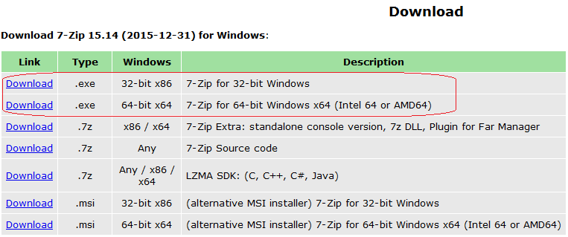

**Video Tutorial**

[**How To Install 7-Zip on Windows 7**](https://youtu.be/v2L5FeXsJf8)

7zip now becomes part of your mouse context menu which will be available when you right click on any archived folder.

**Extract your Kali VM Image**

Once the Kali VMWare image download has completed, Browse to your downloaded image. Right click on the package and select **Extract here.**

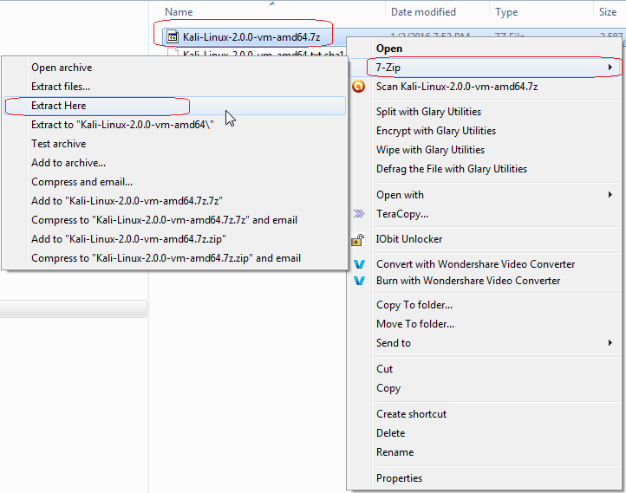

The extraction window pops up. This is a large extraction so be very patient with the process. It can take anywhere from 5 to 10 minutes to complete.

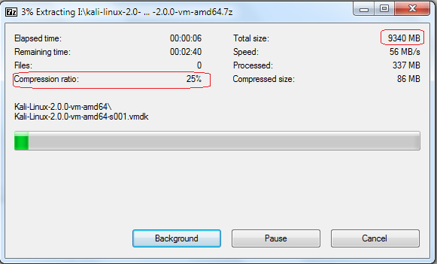

Confirm the folder has been extracted to the same location as the downloaded Kali image. The the file name of numbers will change overtime as newer versions replace older versions. The name of your downloaded file will not match what is shown is the image.

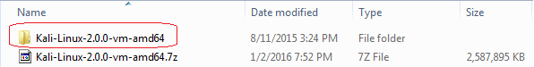

Once your Kali VMWare folder has extracted, the only thing left to do is open VMWare Player or Workstation and import the appliance.

We’re almost done!

From your desktop, find the VMWare player shortcut and launch the program.

(Other than the management console interface, there is no difference in the VMWare wizard for creating or importing a virtual appliance. The major differences are the Workstation Pro costing $250.00, the VMWare Player is free and the Pro version only comes with a 14 day free trial.)

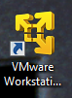

The VMWare Player VM Manager Console Window opens up.

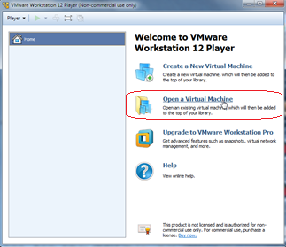

Click on the **Open a Virtual Machine** linkor tile**.**

Browse to the location and open the Kali extracted folder. (Documents>Downloads)

The following VMX image file appears: 2X Click the image file. X2 click the file.

The import Virtual Machine Wizard appears. If you want to change the location of the machine, now is the time to do it by clicking on the browse button and selecting a new storage location.

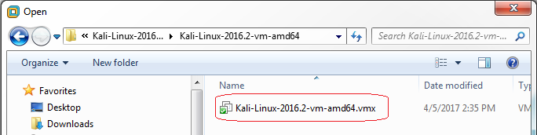

As soon as you x2 click the file, it is immediately placed in the Kali library and read to be started.

**Caveat** – If Your VMWare Player or Workstation errors out with a message like that in the following image, you most probably need to enable VT emulation in your system BIOS.

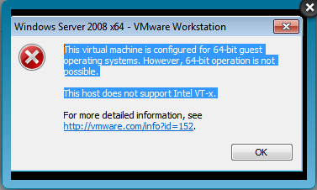

Try enabling virtualization in your systems BIOS. This is particularly true for HP desktops and laptops as they leave the factory with virtualization disabled in the BIOS.

[Verifying Virtualization is Enabled in the BIOS](https://www.dropbox.com/s/6m03kp733l36fz9/Verifying%20Virtualization%20is%20Enabled%20in%20Your%20BIOS.docx?dl=0)

[How to Enable Intel VT-x in Your Computer’s BIOS or UEFI Firmware](http://www.howtogeek.com/213795/how-to-enable-intel-vt-x-in-your-computers-bios-or-uefi-firmware/)

If everything is in place and you do not error out, you are ready to import your Kali image.

The Kali VM Machine is now present in the VMWare Player Management Console. Click on one of the two green arrows start the VM.

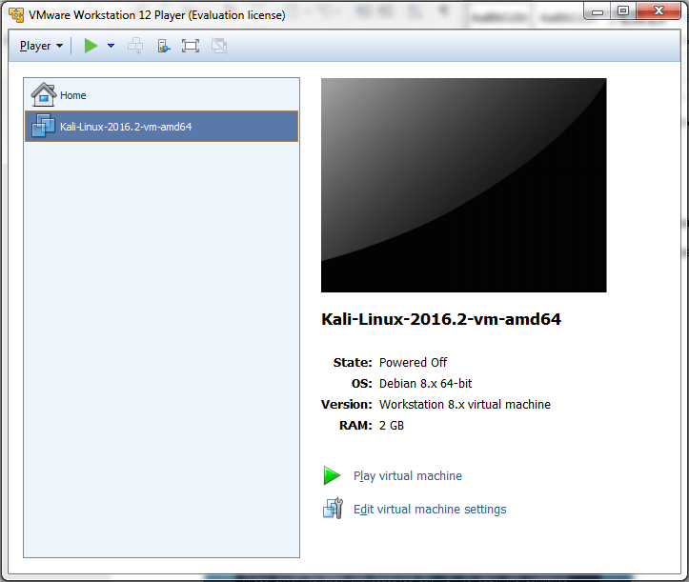

The image starts and boots the desktop.

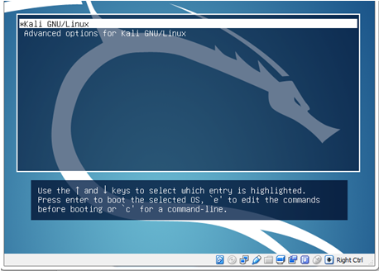

At the logon window the user name is **root**

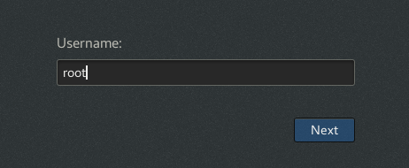

Before you sign in, click on the gear next to the sign in button and change your default desktop from System X11 to GNOME. This is will prevent users from being logged off unexpectedly after opening a terminal session.

The password is **toor**

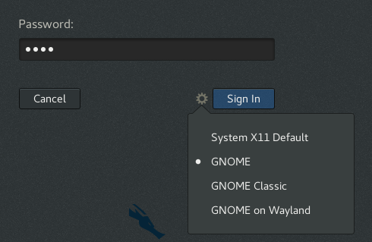

Hit the **sign in** button and congratulations, Kali is now installed

**Stop Kali from logging you out!**

After being idle for just 5 minutes, Kali will you log off. To get back to logon box, hit the enter key. Type in your password of toor

To prevent this from happening, we can adjust the power setting to **never**. At the top right corner, click on the down arrow then the icon for the settings properties.

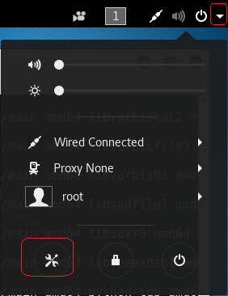

Click on the Power program.

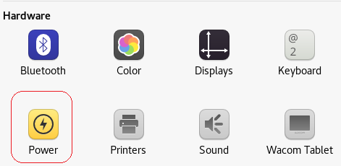

Under Power Savings, pull down the widow to the right and select ‘never’ for the bottom of the window.

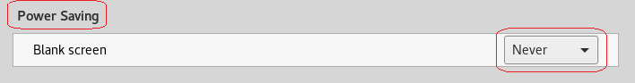

Close the Power window.

To shut down or restart Kali, do it just as if you were gracefully shutting down or restarting your host machine. Do not just power off VMWare as this will corrupt your Kali install!

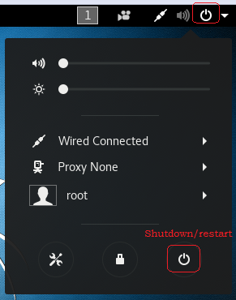

The following screen pops up, select your option.

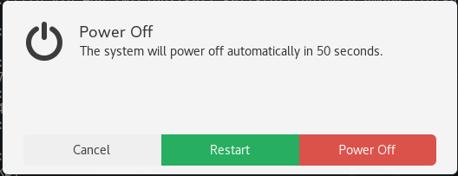

**Updating Your Kali Install and installing the VMWare Tools**

**Caveat!**

**If this is your first time installing and updating a Linux machine, you are in for a genuine real world experience. Linux, regardless of what distro or version you use is all about updating and customizing your install with packages and files on a regular basis. This is a time-consuming process and depending on the quality of your Internet, your hardware, disk space and the packages you wish to install, the updating can take some time to complete.**

**Rules to follow when updating Kali:**

* **You must be patient!**
* **You must not interrupt the update process!**
* **You need to update or things will not work as described in the lab.**

To update Kali open a terminal session and type:

apt-get update && apt-get upgrade -y

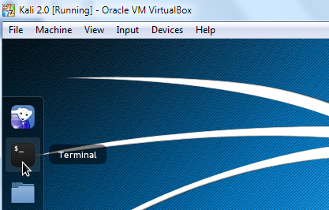

This will make sure Kali checks the most recent repository for any software updates. Once this process completes you can begin the installation procedure for the VMWare Guest Additions.

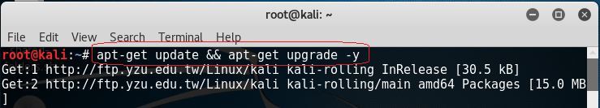

In the VM Menu of the VMware Workstation, Click Install VMware Tools. This mounts a virtual CD-ROM drive containing the VMware Tools installation files.

For VMWare Workstation, Pro

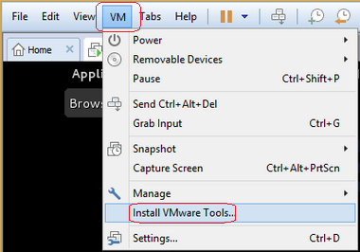

For VMWare, Free Player

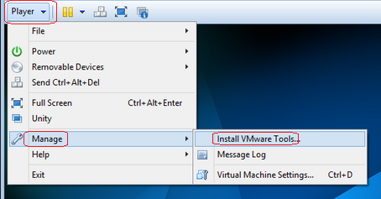

Click **Open With Files** on the pop-up menu inside **Kali Linux**.

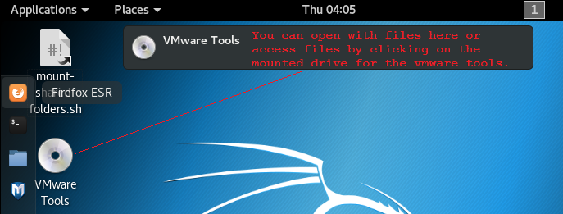

You need to extract VMwareTools-x.x.tar.gz file. To do this, right click the file and then choose Extract To. The version number will change with each new update of VMWare. It’s the only tar file available in the tools folder.

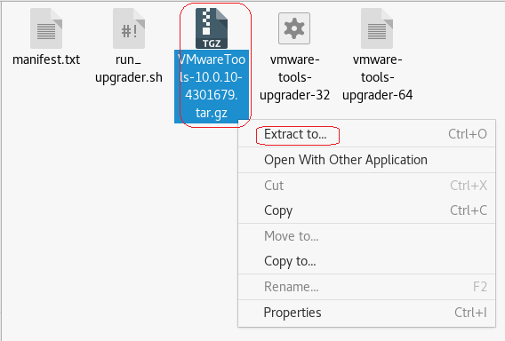

Choose the **/tmp** as your destination.

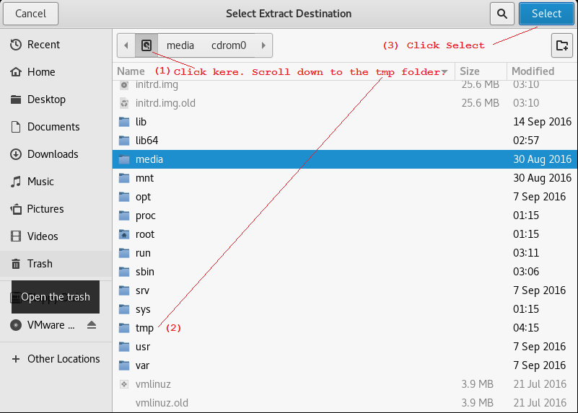

Note the confirmation message.

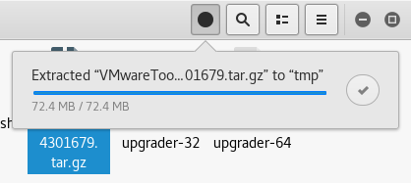

The easiest way to launch the installer is to open files 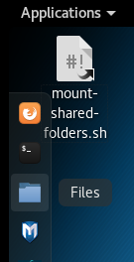

Open **Other locations** 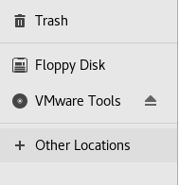 Open **Computer** 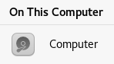

Open the **tmp** folder 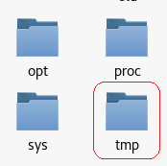

Open the extracted VMWare tools folder 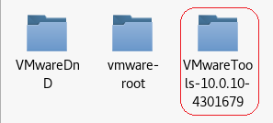

Open the **vmware-tools-distrib** folder 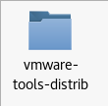

And finally, we x2 click the **vmware-install.pl** 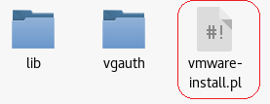

Select Run in Terminal and answer the prompts by affirming each section or excepting the default answer.

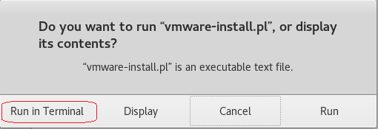

Restart when the install is completed.

**Summary**

As you witnessed, there was no install or configuring of Kali. That’s the magic of using a ready built virtual image. We see a lot of readymade virtual images available from the different distros of Kali. Surprisingly, not from commercial versions of Linux, just the free and open source versions.

Each time you access Kali or any version of Linux, you should run the **apt-get update** command to ensure that you always have the latest packages.

Microsoft also supplies [readymade virtual images](https://developer.microsoft.com/en-us/microsoft-edge/tools/vms/) for their desktop clients. These expire after 90 days but a snap shot (VMWare Pro Version) can be taken any time before they expire and the trial version begins anew. These are designed for developers

The take away for this lab should be:

1. Virtualization is great tool for getting familiar with Linux or any operating system.
2. Readymade images can be used to reduce the learning curve and speed up the learning process.
3. Virtualization is a great way to test for software compatibility issues before you commit.
4. Free does mean inferior.

End of lab!